Contents

Background 1
Accessing BSP AD User Management 1
Check if an AD Account already exists 3
Create a New AD Account 5
Assign AD Groups 6
Account Settings 8

Background

Tableau is a data visualisation software that enables data to be transformed into interactive visualisations (called dashboards) and then shared with users.

Within the University, access to Tableau dashboards is controlled by Active Directory (“AD”) groups. An AD group can be assigned to a published Tableau workbook and all the dashboards within the workbook. Individual users are then assigned to the AD group.

Individuals require Active Directory (AD) accounts in order to access Tableau reports. This guide will instruct you on how to create AD accounts for Tableau users.

 | NB: Tableau AD groups are created by the Microsoft Platform Services Team (“MPST”) in the BSP domain and added to Tableau by the DRAM Business Intelligence team. Our key contacts in these teams are:  - Svetlana Kuznetsova (MPST)  - Matthew Noonan-Nagl (DRAM-BI)  If you ever need to request the creation of a new Tableau AD group, you will need to log an HRIS Standard Incident on OSM and assign tasks to MPST and DRAM-BI asking for help from those teams. You will need to provide both teams with the name of the new AD group to create (e.g. “BIHRStaffDiversityData”).

Accessing BSP AD User Management

From CONNECT Remote Services, select the Administrative Tools icon:

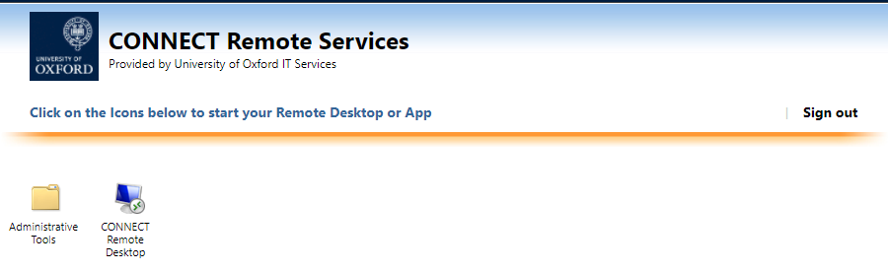

Now select BSP AD USER management:

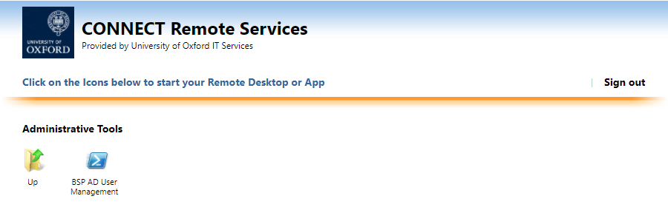

Depending on the browser you are using, you may receive a downloads display prompting you to “Open file” – click the link, if so:

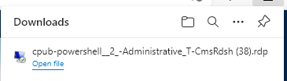

The login screen is displayed. Enter your BSP AD User Management login credentials.
- Your username will be in the format bsp\sso, where the sso is in the format of abcd1234. The password is standalone for this service.

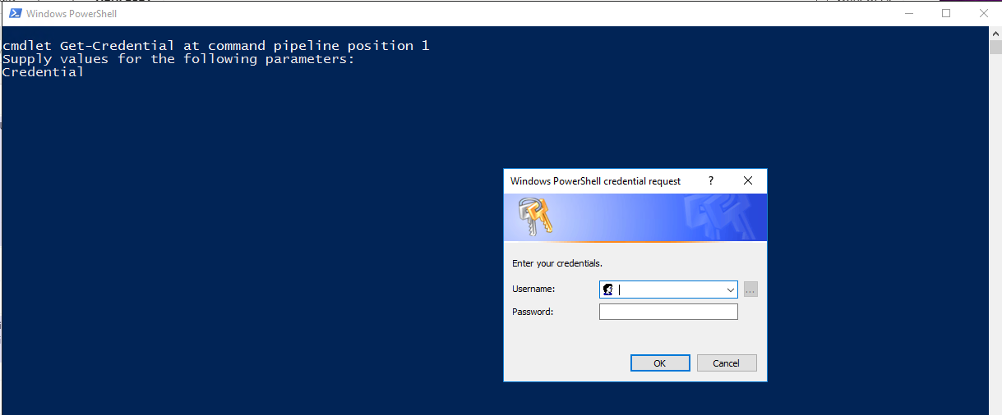

The BSP-ADUC – (Console Root Active Directory Users and Computers) is displayed.

Expand bsp.ox.ac.uk

Expand BSP_Users

Click on Common Users

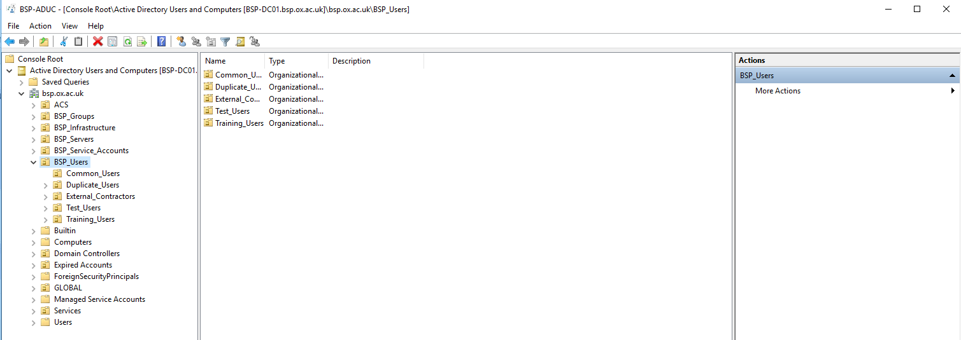

Check if an AD Account already exists

Navigate as described above.

Right click and select Find

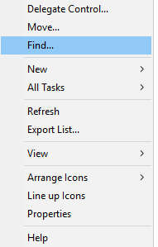

Enter name and click Find Now. The results will be displayed in the bottom section.

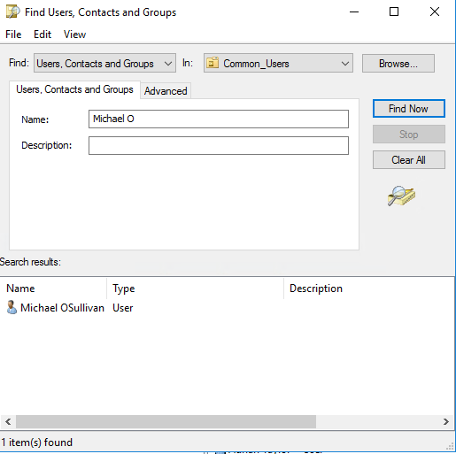

Double click on the name within the results section to open the account details.

Create a New AD Account

Navigate as described above.

Right click and select New > User

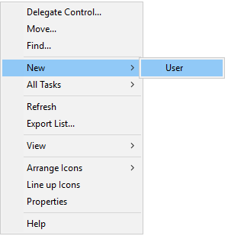

Enter the first name, last name and user login name, which will be the sso as abcd1234. Click Next.

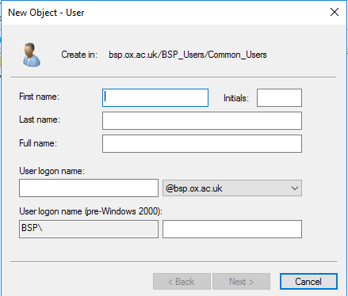

(*****Need to add****Password screen******)

Select the General Tab and enter the email address in full. Click OK.

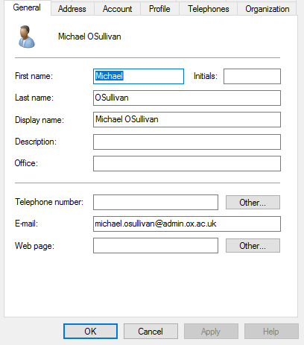

Assign AD Groups

Click on the Member Of tab > Click the Add button
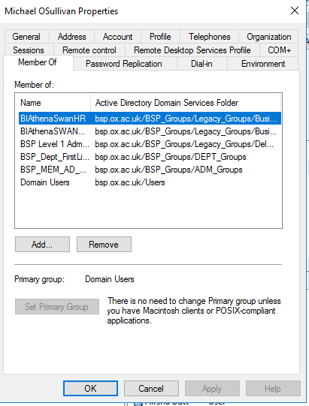

Enter the partial or full object name (AD group name) and click Check Names to review those groups available and select. Click OK

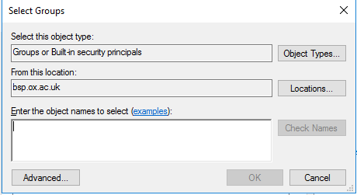

Account Settings

(*****Need to investigate lock and expiry functions further******)

Option to Unlock Account.

Account Expires option to set as Never or End of date.

